Θα σου στείλω και τις φωτογραφίες για να βάλεις διπλά στο κείμενο.

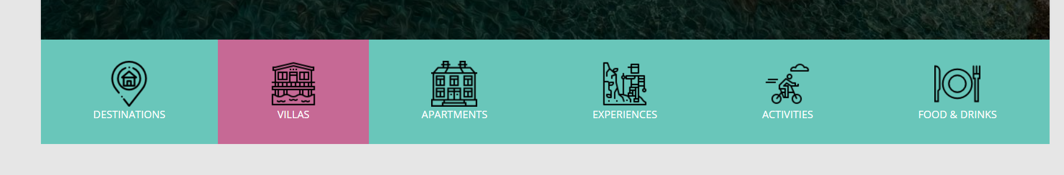

Villas

John & Jenny's Bungalows

Quite family place

Beautifully located between Episkopi village and Agios Andreas, with lashing gardens and few steps from the beach. John and Jenny's Bungalows is one of the best choices to discover the area of South East Messenia.

Built-in 1995 and very carefully maintained, we are offering a sparkling clean space, a different personal approach making our place the perfect choice to relax and unwind.

Price 40 Euros

Noupeli Views

Traditional Stone House at Great Location

Strategically located between Finikounta, Agios Andreas, Peroulia Beach and Koroni, the restored old storage for raisins and olive oil, is the ideal option to explore all South Messenia.

The restoration was completed in 2017 by Elias Kosmas. Elias is passionate about the environment and sustainability usage of local, traditional and sustainable materials like stones and wood.

The loft is the first building that was established in the village in 1832. An ideal place to remotely work, explore and unwind.

Pric € e 50 Euros

**Apartments**

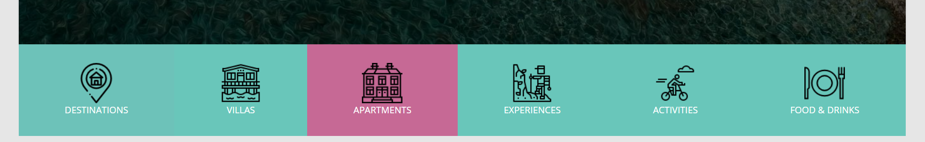

**Seychelles Apartments**

Modern living next to the beach

Located a few steps from a beautiful beach, our recently renovated apartment is offering a great escape for you and your family.

Great food and drinks just a step away, as below you can find "Seychelles, restaurant, cafe and beach bar", with great service, food and sun loungers.

We are looking forward to welcoming you to our great escape at San Andreas!

Price: 70 Euros

**Sofia apartment**

Comfortable apartment around 40sqm, in Logga, easy to access, with Seaview balcony, close to the small medical center, pharmacy, mini market and more.

Just one kilometre away, from the beach of San Andreas, with the great views of Messenian Gulf, we are offering a great place for an easy escape, close to comforts with great levels of safety!

Price: 30 Euros

Experiences

Monastery and Traditional village tour

Explore the amazing nature of Messenia, the flora, and the endless views. All blended together in a tour by foot in the old trails that only the locals know.

You can try it yourself or by a local guide. Starting and ending point can be the tradition kafenio “to steki tis Elenis”, where instructions can be given in three languages- English, Greek and Canadian French- from the owner Dimitris. Follow a path which is leading you to the Moni Grivitsiani, then to Kleisoura village and back.

Price with Guide:20 euros

Local Cooking Class

Learn how to cook two greek dishes in three hours and enjoy on delicious meal, with locally made ingredients.

The local ladies of the village will guide you through the journey, leading you to the secrets of the Messenian and Mediterranean cuisine. After the end of the class a joyful meal will be waiting for you.

Price: 20 euros per person

Olive Harvesting- Seasonal

Between the November and February, the majority of Messenia, is moving from the beach side to the olive groves lands. Experience the production of the best olive oil in the world. Get lost between the enteral trees, feel the nature and the moisture of the grass.

Go through the production from A-Z to the local farmers union factory and observe the green- gold olive oil being produced. All this in a four hours experience.

Price: 20 euros per person

Boat fishing

Enjoy the full experience of a fisherman life. Start you morning very early, hop on the traditional fishing boat, and go to hunt with our experts the more tasty and healthy fish in the world.

Catch the sunrise, feel the sea water and the sea breeze. Help the fishermen, take out the nets from the water, understand the catch of the day and at the end get your piece out of it. Total duration of the whole experience 6 hours.

Price: 40 euros